**A data driven exploration of apple’s IPhones impact in India**

**Submitted by:**

**S. Sandhiya . 2113391083112**

**S. Reetha. 2113391083111**

**M. Swetha. 2113391083117**

**M. Subetha. 2113391083116**

**1.INTRODUCTION:**

Apple's iPhones have become a ubiquitous symbol of technological innovation and sophistication, captivating consumers worldwide since their inception. In recent years, their presence in the Indian market has been increasingly significant, prompting an exploration of the multifaceted impacts they have had on the country.

**1.1.OVERVIEW:**

Apple's iPhones have made a significant mark on the Indian landscape, transcending the boundaries of technology to touch various aspects of the nation's society and economy. India, with its vast population and burgeoning smartphone market, presents a unique and complex backdrop for the influence of Apple's iconic devices.

**1.2.PUREPOSE:**

The purpose of such a study can vary depending on the specific research goals and the interests of the audience. It can serve as a valuable resource for policymakers, business leaders, researchers, and anyone interested in the complex interplay between technology, society, and economics in a rapidly evolving market like India.

3.PROBLEM DEFINING& DESIGN THINKING:

Problem definition is a critical step in the design thinking process. It involves identifying and framing the issue or challenge that needs to be addressed. Design thinking is a human-centered approach to problem-solving, and it typically consists of several stages, with problem definition being the first. Here’s how problem definition and design thinking relate:

**2.1.Empathy map:**

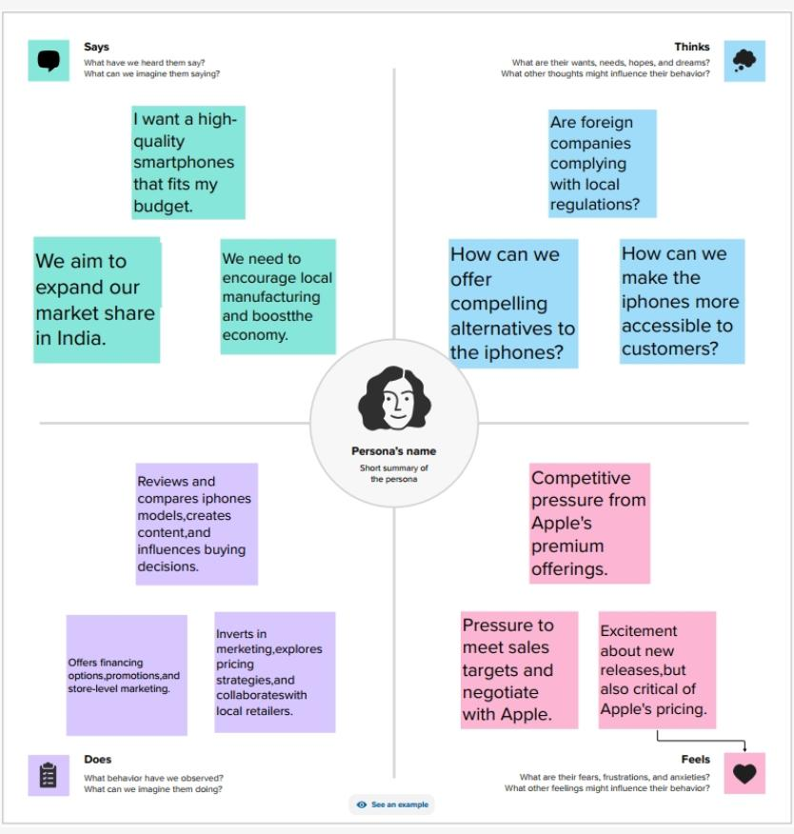

**2.2.BRAINSTORMING:**

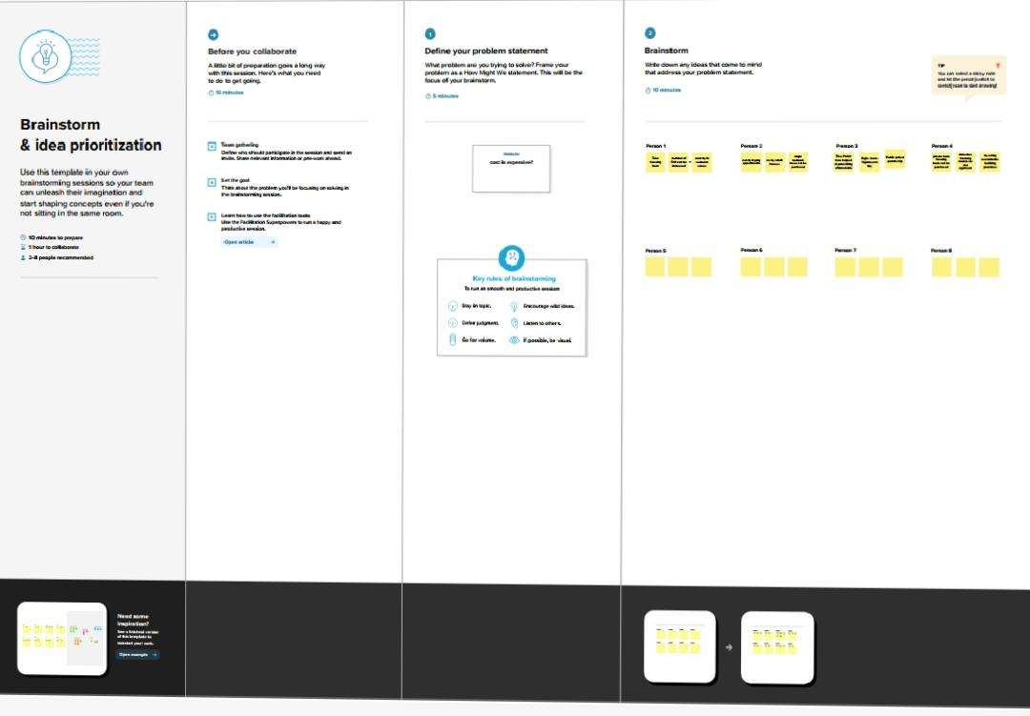

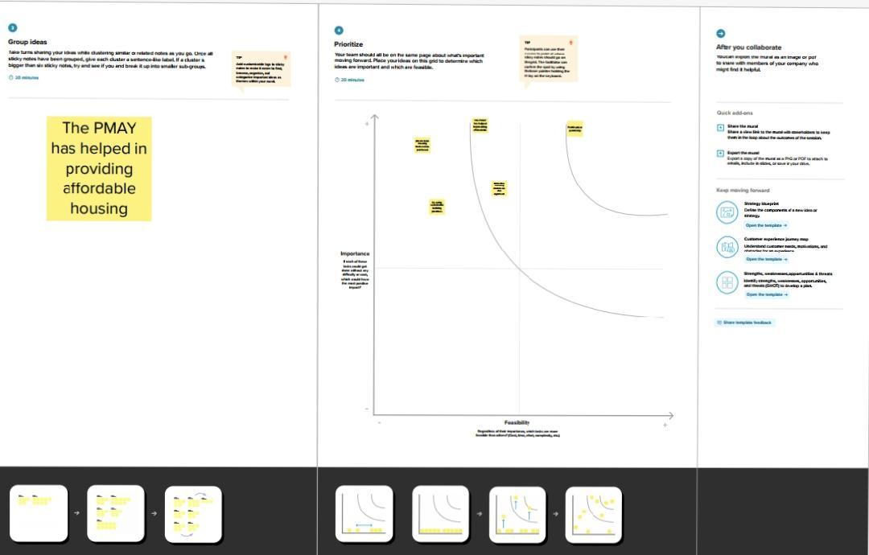

**3.RESULT:**

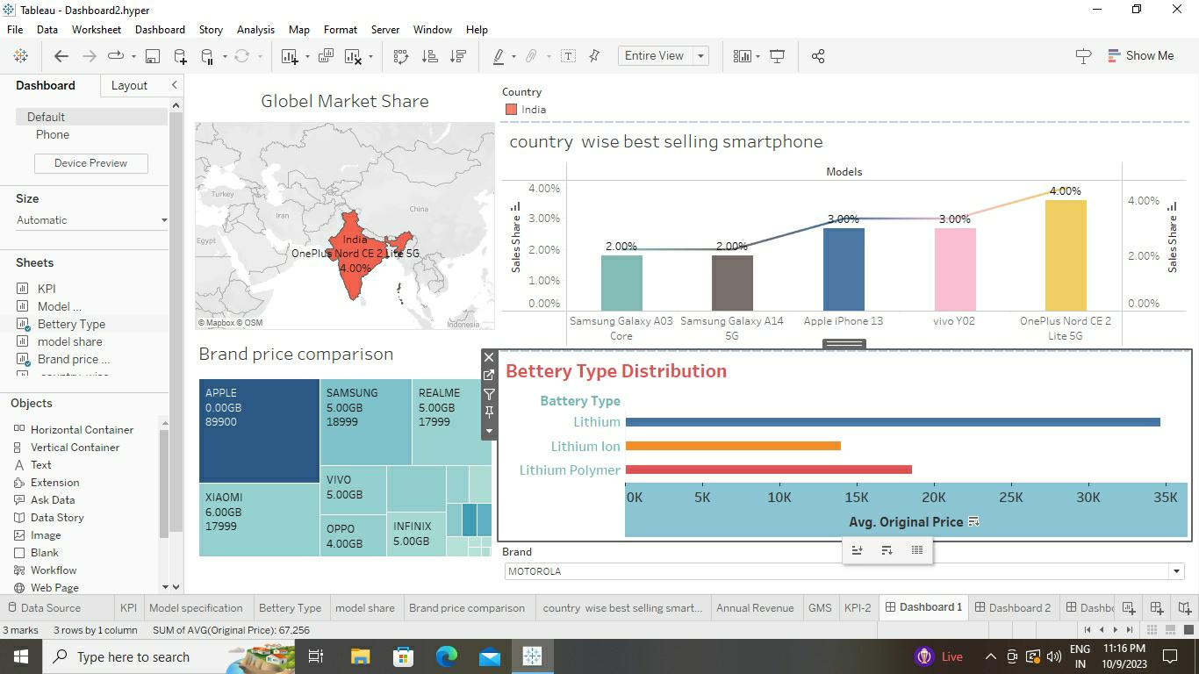

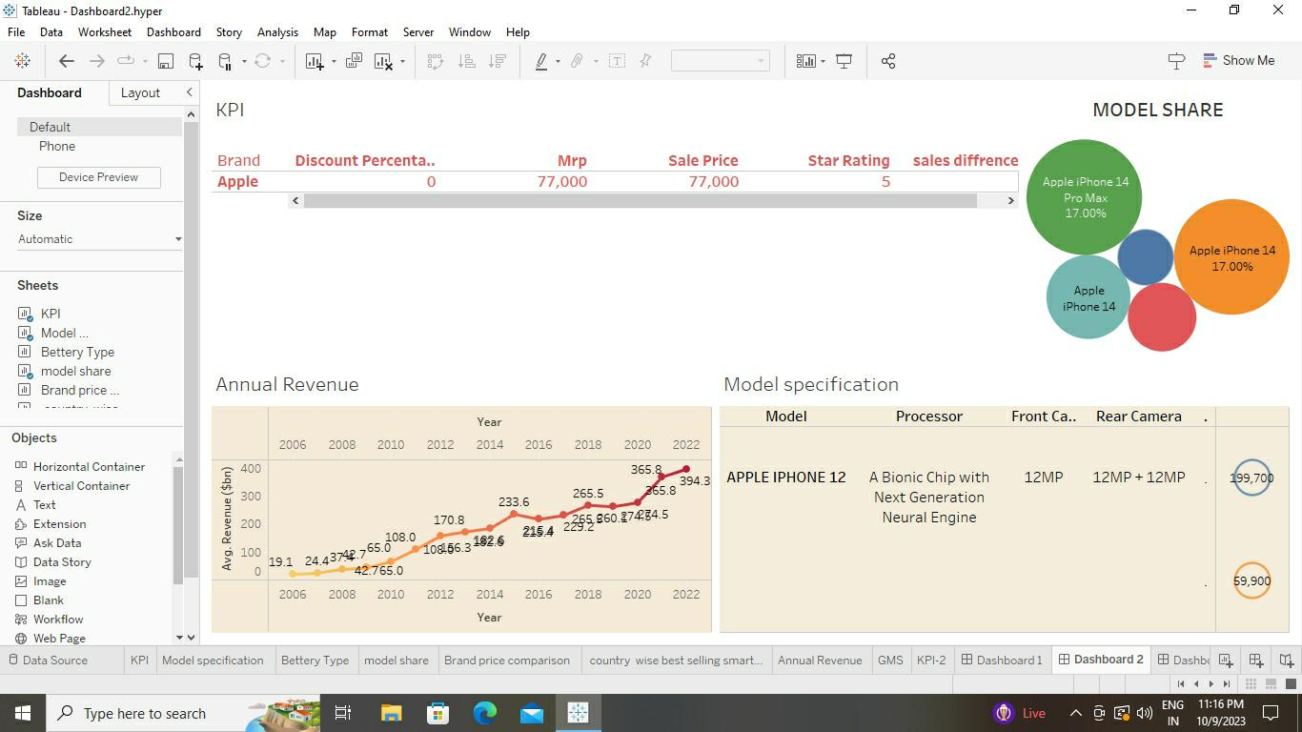



**4.1.ADVANTAGE:**

Problem definition provides a clear and concise understanding of the challenge to be addressed. This clarity helps keep the focus on solving the right problem, which is essential for efficient problem-solving.

Problem definition is based on insights gained from empathizing with users. This ensures that the problem is framed from a user-centric perspective, leading to solutions that better meet user needs.

**4.2.DISADVANTAGE**:

A rigid problem definition can lead to over-commitment to a particular problem statement. This can be problematic if new insights emerge during the process that suggest a need for adjustments to the problem statement.

Problem definition is influenced by the initial insights gained during the empathize stage. If these insights are biased or incomplete, the problem statement

**5.1.APPLICATION:**

In product design, clearly defining the problem helps teams create products that address user needs and pain points effectively. This can apply to physical products, software, or any other design-related endeavor.

**6.cCONCLUSION:**

In conclusion, problem definition is a pivotal step in the design thinking process that plays a crucial role in guiding problem-solving and innovation across various domains. It sets the foundation for a human-centered approach to addressing challenges and creating solutions. Through the empathize, define, ideate, prototype, and test stages, design thinking leverages a well-defined problem statement to generate creative, effective, and user-centric solutions.

**7.FUTURE SCOP:**

**With the ongoing digital transformation of businesses and services, problem definition will be essential for identifying digital challenges and opportunities. This includes designing user-friendly interfaces for emerging technologies, addressing cybersecurity issues, and enhancing online user experiences.**